Recommended Thespian Point Awards
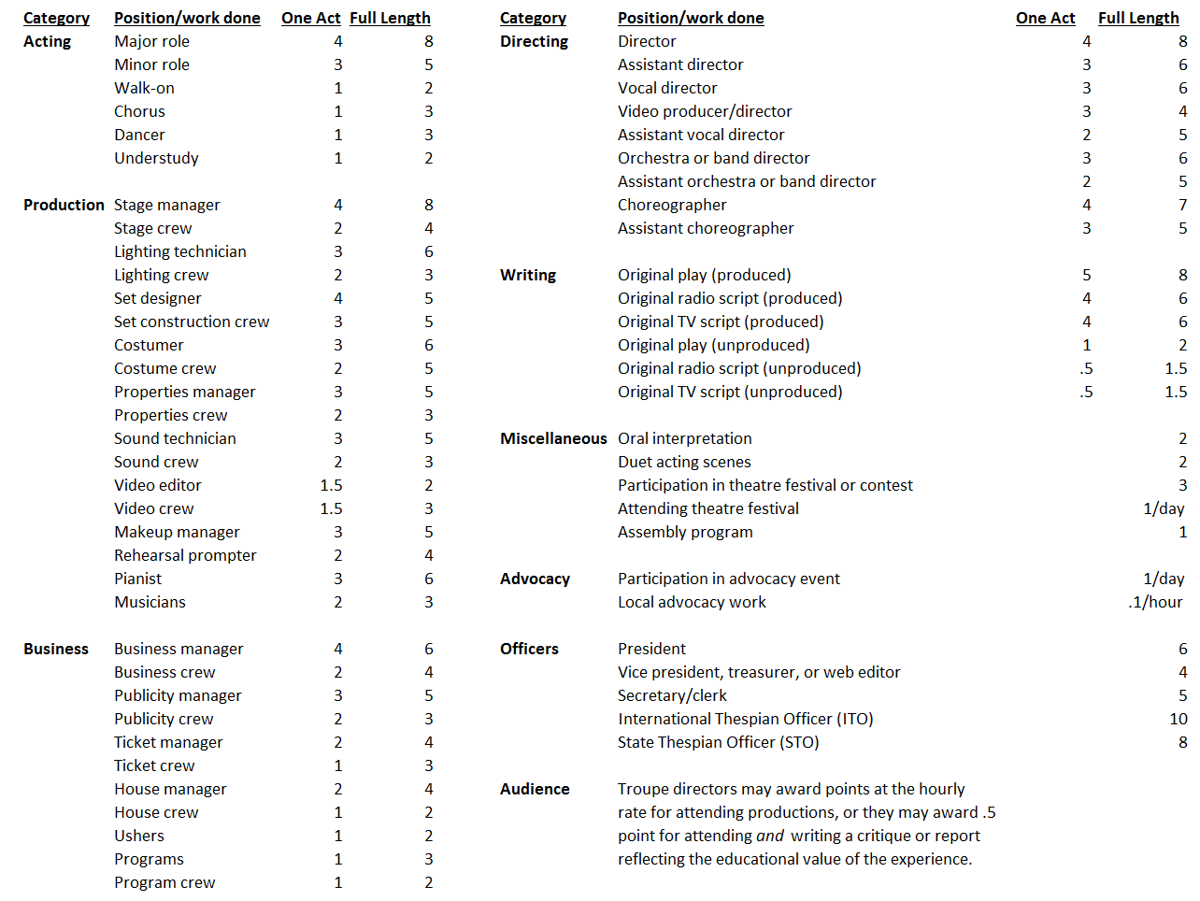

Thespian Honor Rank Summary
(see Thespian Troupe Handbook for details)
